### CS-639 Building User Interfaces, Fall 2019, Professor Mutlu

# Assignments — Week 02 | Design | Think-aloud + Ideation

In this assignment, you will practice the "empathy" method that will give you the most bang for the buck in terms of understanding user needs, preferences, and behavior. The think-aloud protocol involves (1) identifying users who represent your target group of users, (2) identifying/developing tasks that represent the functioning of the target system, (3) observing users as they perform the tasks, (4) analyzing your data to develop design insight, and (5) ideating design solutions that are informed by the insight you developed from your data. Imagine that you are given the task of redesigning UW–Madison's course search and enrollment system and follow the process below to perform a think-aloud and ideate for solutions.

### Think-aloud

**Step 1. Identify users.** Who are the users of the UW–Madison course search and enrollment system? Describe below the characteristics of this user group, identify one person who might be willing to take part in your user research, and ask the person for their interest/availability. (If the person you identified is in this class, it is acceptable to swap roles.)

**Fredie Lee, Actuarial Science Major, Finance Major, interested in Basketball, available on Wednesday 7pm for research.**

**Step 2. Identify tasks.** Study the course search and enrollment system and make a list of the main tasks that users of the system might be performing using the system. Rank your list in terms of importance (simultaneously considering impact, frequency, prevalence) and identify the top three tasks. Describe each task in 1–2 sentences in a way that your users can understand.

1. **Choosing a class using DARS and Class Scheduler**

**Choosing a class based on the credit requirements, searching courses based on filters, as well as making a schedule using the built-in scheduler.**

1. **Enrolling in a class.**

**Choosing a course, adding it in to the cart. Then successfully enroll in the class.**

1. **Dropping from a class.**

**If the class is unwanted, knowing how to go to the list of classes enrolled and dropping it.**

**Step 3. Perform think-aloud.** Hold a think-aloud session with your representative user. First describe to your user how the think-aloud will work (refer to the reading and class notes), describe the tasks one at a time (answer any questions you might have), and ask them to perform each task while they say out loud what they are thinking.

**Pro tip:** If you see your user performing the task but not speaking, probe them by asking what whey are thinking or reminding them that they should be describing.

As you observe your user performing the tasks, take notes (using the other sheet) of important actions, problems they encounter, confusions they might voice, and so on. For anything that stands out, after each task, ask your user why they did that or said that. Your observations and notes will form your data. Include your data in the data sheet provided at the end of this document.

**Fredie thinks that it is hard to look for a course that fits his schedule because he had to manually click all the classes and look at the times.**

**He couldn’t find a way to use the scheduler to schedule waitlisted classes.**

**He could still add courses to cart even if he isn’t eligible to enroll.**

**When finding drop button, need to select a class for the drop button to show.**

**Step 4. Create insight.** In your data (e.g., notes), highlight where you saw significant breakdowns in functioning, need for better functioning, or user preferences that would require an alternative design. Make a list of your findings as design recommendations.

* **Add a message that shows the class is in conflict with other enrolled classes if user adds course to cart (if a discussion section is selected or only one lecture option)**
* **Add a warning message that tells the user that the course added to cart isn’t eligible for enrollment.**
* **Have a checkbox to provide options to include waitlisted or enrolled classes in scheduling**
* **Make the drop button always show but greyed out if a course isn’t selected to indicate the user that they are at the right place to drop the course.**

Ideation

**Step 5. Ideate.** In this step, hold a brief ideation session individually. First focus on generating ideas, and then critique these ideas in terms of how well they address the problems you identified in your think-aloud. Include sketches of two of your ideas below. Remember that these should be conceptual designs and not wireframes or illustrations, focusing on the core idea of a design and not on design elements. You can draw on paper, take a photo, and include the photo below; draw on a tablet computer and carry over the image here; or draw using the drawing tools of a word processor. Remember, these should be very simple drawings just to convey the idea.

<describe-your-designs-here>

Idea 1

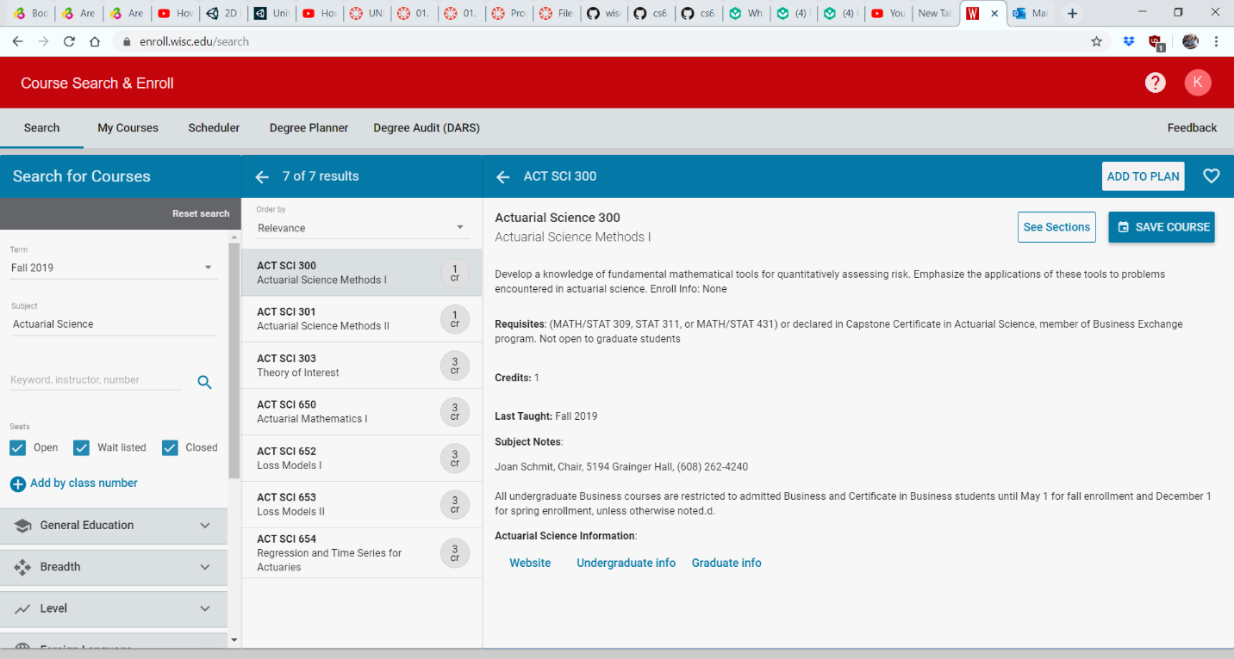Since it is troublesome sometimes to have to go the cart to handle everything(check for eligibility, select sections, enroll etc.) It is possible to add a enroll button next to the “Add to Plan” button so that user that know they would want to enroll the course with 100% certainty can do so with ease. If the user is unable to join the course, display an error message.

Unable to join the course.

*Details such as requirements not met*

*fades away in 3 seconds*

Enroll

Idea 2

For courses that were added to the cart, do a check with the currently enrolled courses, or courses on the waitlist, then print out the details on a fade-away message on the screen. A link can be included so that the user can decide to undo the course add if it is in conflict with another more important course.

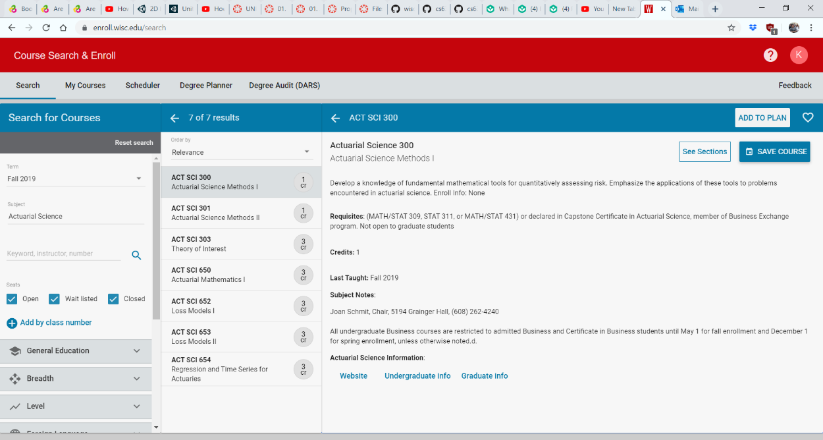

The course you just added to cart conflicts with *course name*.

Remove course

*fades away in 3 seconds*